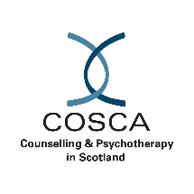

CrossReach Perinatal Volunteer Counsellor opportunity

We are looking for experienced volunteer counsellors (qualified or in training) to join our Perinatal service.

**CrossReach Perinatal Service** offers support to parents and families expecting a child, or whose youngest child is under 3. Our trained counsellors and therapists are experienced, compassionate and offer support without judgement. We offer support to those experiencing anxiety, depression, low self-esteem, trauma or any other difficulties before or after having a baby. The team offers a wide range of therapies to ensure the best type of support is received: Individual counselling; Group counselling and Perinatal therapy specific to new and expectant parents.

Our volunteers deliver support from our Edinburgh city centre premises as well as remotely by phone and video calls between the hours of 9AM – 5PM, Monday to Thursday.

Volunteer applicants are asked to either be fully qualified or working towards their diploma / post graduate diploma, having already completed a minimum of **80-100 clinical hours**.  The clinical team are particularly keen to hear from applicants who have relevant life experience and or interest in the field, as well as availability to volunteer on **Mondays, Tuesdays** or **Thursdays.**

For more information and how to apply please visit:

<https://www.jobtrain.co.uk/crossreach/Job/JobDetail?JobId=12401\>

Closing date: **Sunday 29th September 2024**

CrossReach Counselling is an organisational member of COSCA and adheres to COSCA’s Statement of Ethics and Code of Practice.